Timesheets instructions (2025)
Here are brief instructions for recording working hours in the Capstone course.
In the beginning
- Download AIMlearning. Timesheets –Excel file to your computer.
- Save the Excel file on your computer and name it in the following format
  - Company name. Timesheets. Your Name
  - Example. Example Oy. Timesheets. Eric Example
Mark in table
- Month of booking Time of entry.
- The date of the entry (the number on the left-hand side of the page indicates the date. This number must not be changed!
- Description of the day's tasks (avoid repetitions and short sentences).
- Start and end time. (Login in and out)
- Total project time of the day to 2 decimal places.
  - e.g. If you do 7 h and 30 min during the day, enter it in the table 7.50
  - Decimal converter
    - 15 min = 0,25
    - 30 min = 0,5
    - 45 min = 0,75
    - 1 h = 1,00
A correctly completed form will calculate the total work time for the month at the bottom of the page.
If you don’t work on projects on weekends, you can leave the field blank or enter WEEKEND as a comment.
Only hours related to project work are recorded in the timesheet! Examples: Team meetings, planning and research work, implementation and testing of solutions, presentation of work in class, etc.
Keep track of your working hours on a monthly basis. Add one month's working hours to a single spreadsheet page and name the spreadsheet after the month for which the working hours have been recorded.
E.G.

Add a new table
When a new month changes, copy the "Copy only" tab and name it the next month for which those hours are worked. DO NOT SAVE ANYTHING TO THE COPY ONLY PAGE! ALWAYS TAKE FIRST A COPY OF THE COPY ONLY PAGE, WHICH IS THEN FILLED IN!

E.G
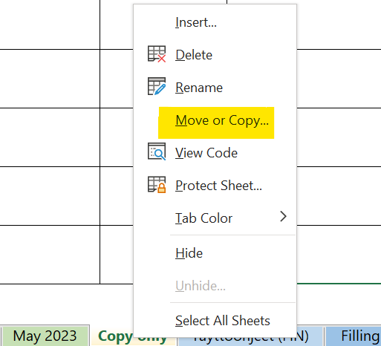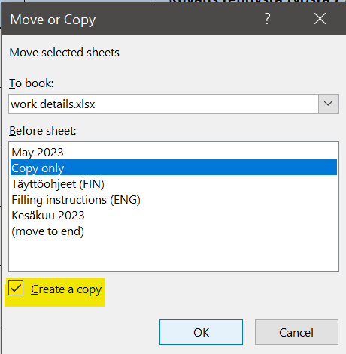
Below is an example of filling in the table
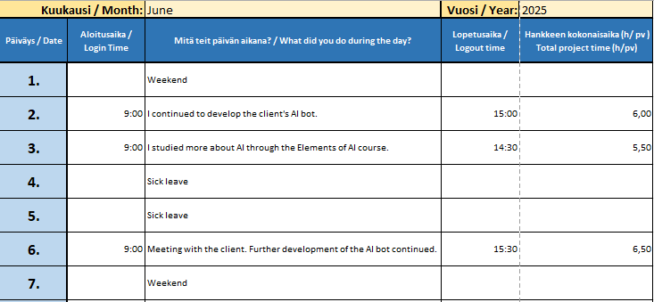

If there is no specific day of the month (e.g. 30th or 31st), leave the box completely blank. Fill in only one month/table.
The completed timesheet must be returned to your instructor in .xlsx format according to the instructions provided.

